A1041-Am,S-Colombia-Calima-S Highlands-Squatting Male with Burden Basket-ca 200 BCE–400 CE

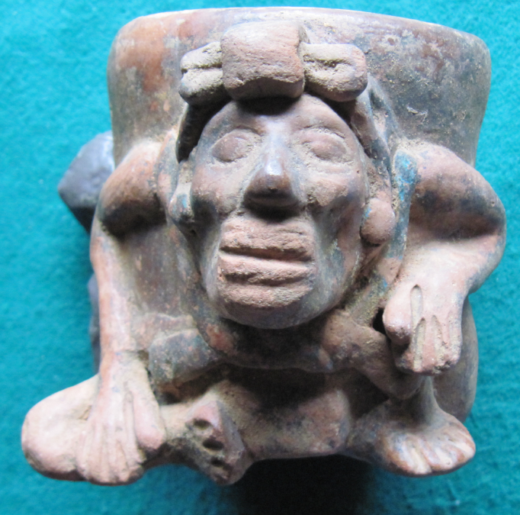 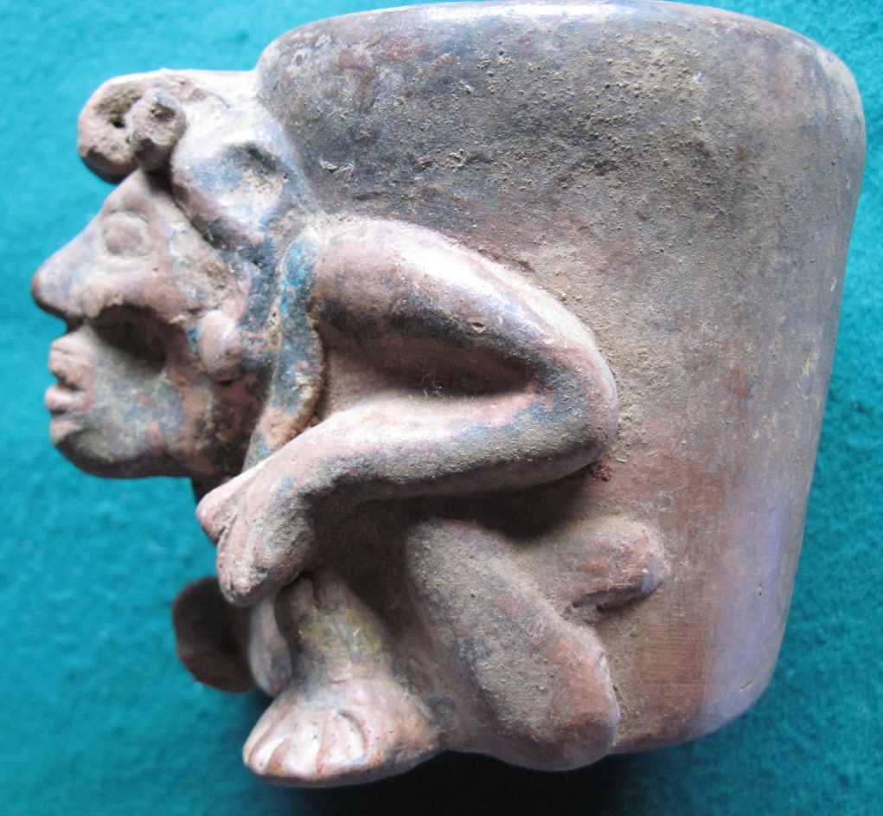

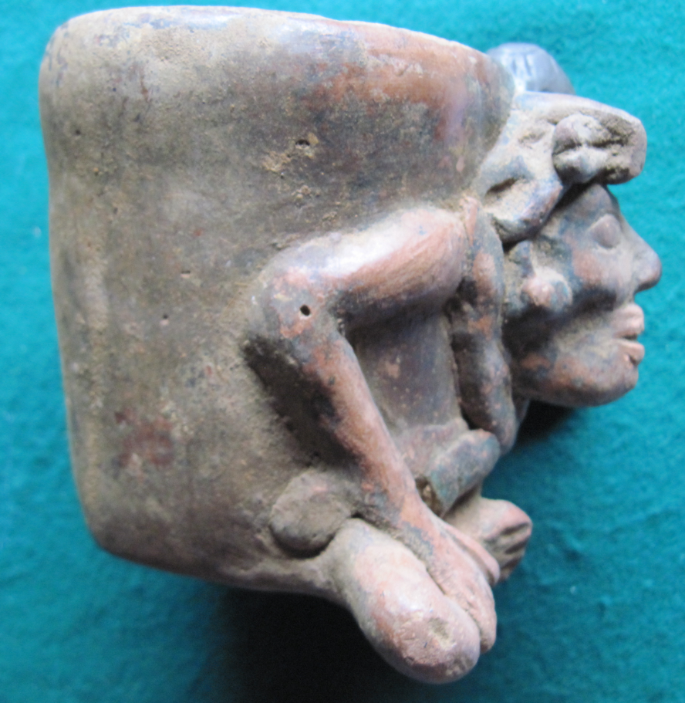 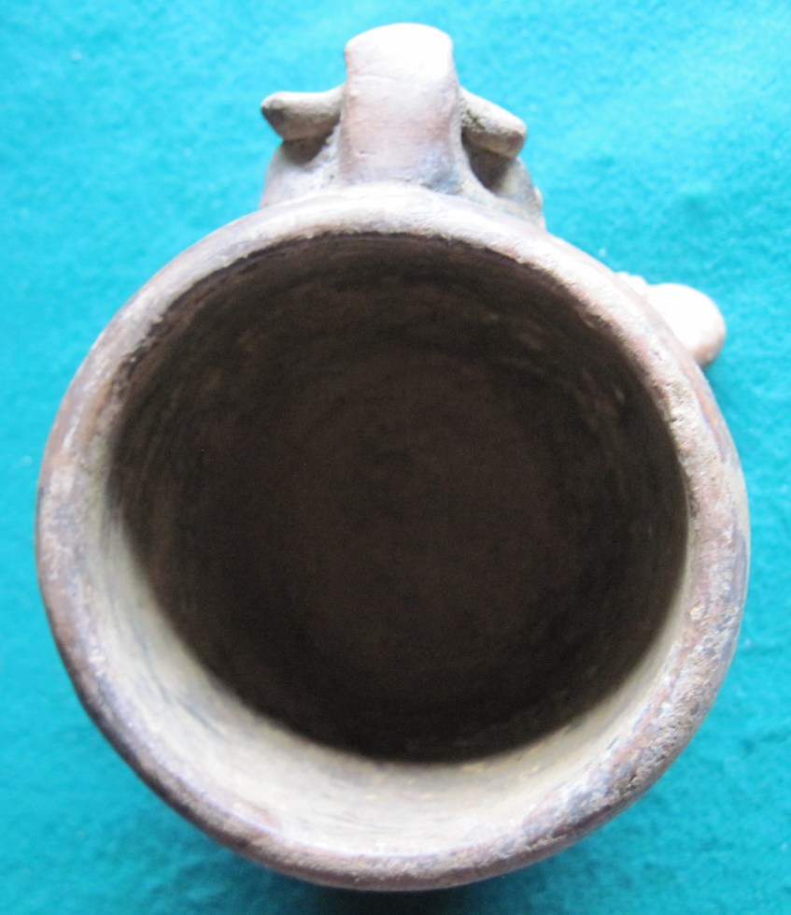

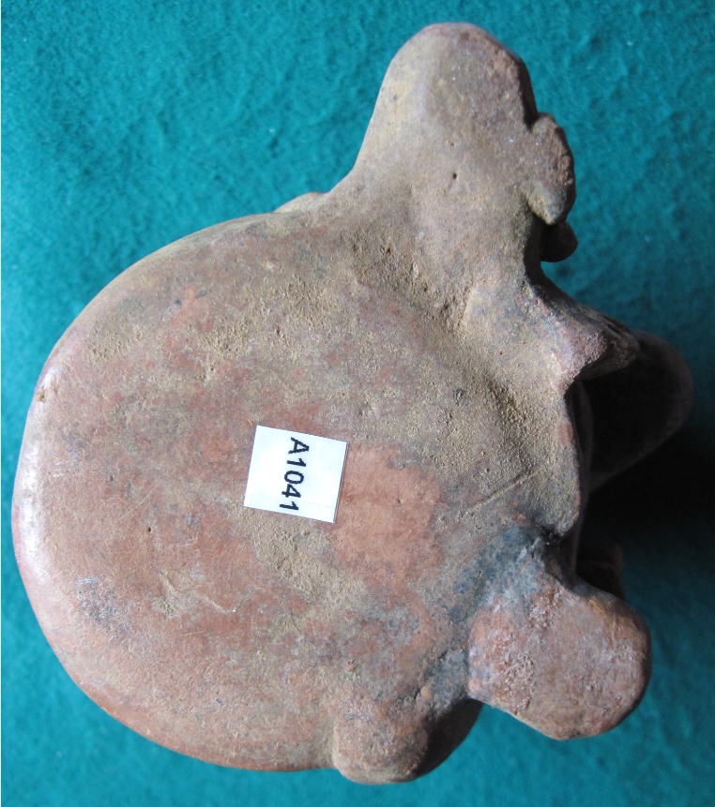

Figs. 1-5. Colombia-Calima-S Highlands-Squatting Male with Burden Basket-ca 200 BCE–400 CE

**Case no.:**

**Accession Number: A1041**

**Formal Label:** Colombia-Calima-S Highlands-Squatting Male with Burden Basket-ca 200 BCE–400 CE

**Display Description:**

Calima culture (200 BCE–400 CE) was the successive amalgamation of Ilama, Yotoco, Sonso, and Malagana cultures in the Valle del Cauca in Colombia. This culture produced two distinct styles of facial masks that applies to this figurine’s facial structure. One was with protruding cheeks and hollowed eyes as in this figurine, while the other style emphasized wrinkled skin and was painted reddish brown (Shelton 1996: 209-210). It is implied by the figure’s facial expression that he is under great strain , possibly as a slave.

**LC Classification:** F2270.2.C24200 BCE–400 CE

**Date or Time Horizon:** ca

**Geographical Area:** [Valle del Cauca](https://en.wikipedia.org/wiki/Valle_del_Cauca) in [Colombia](https://en.wikipedia.org/wiki/Colombia).

**Map, GPS coordinates:** 4.71674 -76.01663;40° 26' 46" N 79° 58' 56" W.

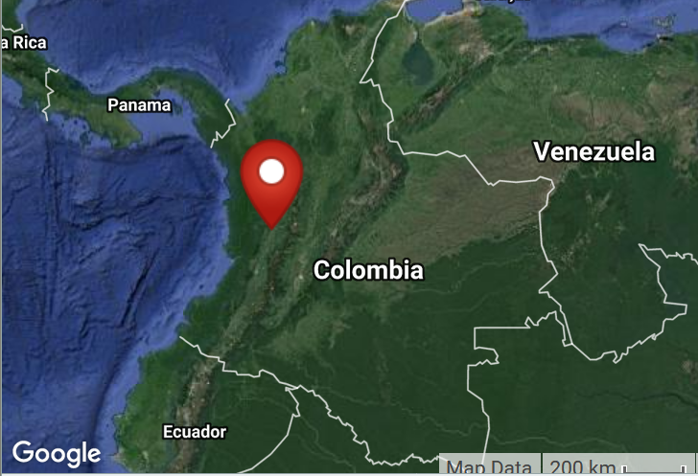

**Map of location of** [Valle del Cauca](https://en.wikipedia.org/wiki/Valle_del_Cauca) in [Colombia](https://en.wikipedia.org/wiki/Colombia).

**Cultural Affiliation:** Colima

**Media:** ceramic

**Dimensions:** H 97.31 mm; 6.35 in.

**Weight: 263 gm; 9 ¼ oz.**

**Condition: original**

**Provenance:** unknown

**Discussion:**

The four cultures that make up the Colima are:

1. Ilama culture

By 1500 BCE the Ilama culture, the first Agricultural-Pottery society, appeared along the Calima River, near the present day towns of Restrepo and Darien. Its society had a social structure of Cacicazgos (chiefdoms) that prevailed until the arrival of the Spaniards. The economy of Ilama was based on textile weaving, metallurgy, hunting, fishing, and agriculture. Yuca and beans were primary crops. The Chief or Cacique was the leader of the settlement. Other occupations were Chamanes (spiritual leaders), warriors, farmers, hunters, pottery men, and goldsmiths. Their ceramics were typically red and black, featuring religious imagery.

1. Yotoco culture

By 100 CE the Ilamas developed into the Yotoco Culture, which expanded their territory further into the Cauca River and the Pacific Ocean and to the south to the region of what is now the city of Cali.

The Yotocos prevailed in the region until 1200 CE and were a highly stratified society headed by caciques, which managed several settlements. The population had increased, forcing them to develop effective agricultural techniques to feed its population which also improved the techniques on pottery and metal works. They created polychrome ceramics and introduction of hammered goldware. The agriculture of the Yotocos was more varied than that of the Ilamas and was based on maize, yuca, beans, arracacha, achiote among others. The Yotoco started declining in the 6th century CE.

1. Sonso culture

Sonso culture (500–1200 CE) flourished during the Late Period I. Population increased, government became more centralized. Sonso culture was marked by fewer ceramic styles, and their goldware was lost wax cast tumbaga.

1. Malagana culture

The primary archaeological site for Malagana culture is Malagana. Dating from 300 BCE to 300 CE, the site was discovered in 1992, and an estimate four tons of artifacts were looted from it in a matter of days.[[2]](https://en.wikipedia.org/wiki/Calima_culture#cite_note-2) This culture produced fine, burnished ceramics, predominantly white or terra cotta in color. Ocarinas, large bottles, and alcarrazas, double spout and bridge vessels, become common.

**References:**

Morand, Calima, Marie-Claude Marianne Cardale de Schrimpff; Theres Gähwiler-Walder; Fondation Pierre Gianadda. 1991. *Colombie précolombienne*. Lausanne: Editions Payot; Martigny: Fondation Pierre Gianadda

Shelton, Anthony Alan. 1996. “South American, Pre-Columbian sec. VIII, 4 (ii) Masks: Chronological and regional styles.” In *The Dictionary of Art*, ed. Jane Turner. London: MacMillan, v. 29: 209-210.

.